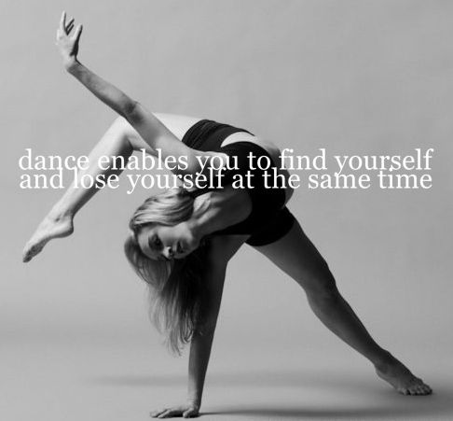
CORONADO DANCE DEPARTMENT DANCE I-IV
2016-2017
Dance Room- Fine Art Center
Dance Office – C 34-A
Dance Director: Josey Mitchell
Contact: jmpicket@episd.org, coronadodance.weebly.com, twitter:@coronadodanceco
Facebook/Instagram/Snapchat: Coronado Dance Company

Required Materials:
- Lock
- Laptop

Required Dancewear:
- Ladies: Black leotard, black dance shorts, leggings, or skirt, nude, pink or black tights, jazz shoes or ballet slippers, dance department spirit shirt.
- Gentlemen: Black or white t-shirt, black pants or shorts, black jazz shoes or ballet slippers, spirit shirt.

Course Description (1 Fine Arts Credit):
I hope you feel a great sense of accomplishment and self-confidence as you learn more about yourself, the people and the world around you through dance!
This year you will learn about a wide range of dance styles including: social dance, hip-hop, jazz, musical theater, ballet, modern and contemporary dance. You will also have opportunities to perform, choreograph and critique dance. You will document your progress and share your work through a digital portfolio.

Course Standards: TEKS - http://ritter.tea.state.tx.us/rules/tac/chapter117/
National Dance Standards - http://www.nationalartsstandards.org
Grading:
PARTICIPATION 50% Daily grade
DIGITAL PORTFOLIO 30% Research projects, Notes, Critiques, Websites, Resumes, Journal entries
PERFORMANCES 10% Fall & Spring dance shows, Homecoming pep-rally and others
9 WEEKS TESTS 10% Practical exams, presentations

*Rubrics will be discussed and formulated together in class for each particular activity.

Dance Class Etiquette and Expectations:

ATTENDANCE
The TEKS require that the majority of the courses are based on physical demonstration of dance skills. Therefor it is extremely important that you are present in class for 90% or more of the scheduled school days. Three or more absences from a rehearsal for a piece will result in removal from the performance.

FULL PARTICIPATION
Never sit down in the middle of dance class unless it in an emergency. If you are too sick to participate you will be sent to the nurse. You must have a note from a doctor or the nurse in order to be excused from physical activity. Suit out and participate =100; Don’t suit out and participate = 50; Don’t suit out and don’t participate = 0. Student will receive credit for suiting out only if wearing the required dance wear. All students have two weeks from the official first day of school to get the required dance wear.

BE ON TIME AND COME PREPARED FOR CLASS.
The first and last three minutes of class are reserved for checking in, changing and taking notes. Use your time wisely. You must be in the Fine Arts building and check in by the time the tardy bell rings. You will change in the fine arts dressing rooms or restrooms. No use of cell phones in the bathroom or dressing rooms. This is a private space where people should feel comfortable changing.

WEAR PROPER DANCE CLOTHES
Dancewear is designed so that you can move properly. It is supportive and shows the line of the body. Only wear approved dancewear. You must follow school dress code. Never leave the dance studio/gym in your dancewear unless approved to do so. No jewelry. This includes: Necklaces, rings, bracelets, facial/body jewelry and long earrings (studs are ok). Hair pulled back securely in at least a ponytail, bun for ballet. LABEL ALL OF YOUR DANCE CLOTHES. Monday through Thursday all black. Friday you may wear different colors but still must wear dance clothes.
* Dance wear can be purchased online at discountdance.com using teacher code 44005 to view the suggested dress code and for use at check out for the Coronado Discount.

RESPECT THE DANCE STUDIO & DRESSING ROOMS
No Gum, Food or drink, except a closed container of water, is allowed. No street shoes are allowed in the studio. This track in dirt and ruins the floor and is unsanitary. Leave all personal items organized and in a safe place. Do not touch or move other people's personal belongings. Clean up after yourself. Respect other peoples' space. Dance and exercise equipment should be used in a safe way.

FUNDRAISING & AFTERSCHOOL REHEARSALS/PERFORMANCES
All students will be expected to participate in fundraising activities to purchase costumes, pay for field trip expenses and other materials. At the time of a major performance you will be expected to attend scheduled after school rehearsals and performances as 10% of your grade for this course. You will also be required to attend and write a critique of at least one dance related event outside of Coronado High School per semester.

Tentative Course Activities:

Topics Dance Styles Performances Projects
1st 9 Weeks  Creating portfolios, dance history and technical foundations, setting goals | Conditioning for Dance, world dance, social dance, modern/contemporary | Homecoming pep-rally  Fall Show – Identity | Create your portfolio (website)  Goal Setting  Dance Styles/Pioneers Presentations
2nd 9 Weeks  Dance Performance, Contemporary Dance, Ballet, Dance Critique | Modern/Contemporary, Ballet | Holiday Show  Possible Field Trip | Dance Critiques  Build Word Wall
3rd 9 Weeks  Jazz, Musical Theater, Developing as a performer | Conditioning for Dance, Ballet, Jazz, Tap, Musical Theater | Dance Festivals  Spring Show  Possible Field Trip | Building your portfolio
4th 9 Weeks  Elements of Dance, Dance and Technology, Leadership, Auditioning | Hip-Hop, Improvisation, Composition | Student Choreography Showcase  Dances for Film  Teach a combination( Dance 2-4) | Choreography/Dance for Film Presentation  Building a Resume  Leading the Class
*Dates and performances are subject to change.

I have read and acknowledge the course expectations academically and behaviorally expected as a member of the Coronado Dance Department. I also acknowledge the materials and dancewear required of the course.

_________________________ _____________________________
Student Printed Name Parent Printed Name

______________________________ _____________________________
Student Signature Date Parent Signature Date

Student Contact Info: Parent Contact Info.

Phone: Phone:

E-mail: E-mail:

